- Static page is appearing at school information page if school’s profile is not completed.
- Validation message language of image size.
- School page >> Carousel images >> When user upload many images then UI of uploaded images are not proper.
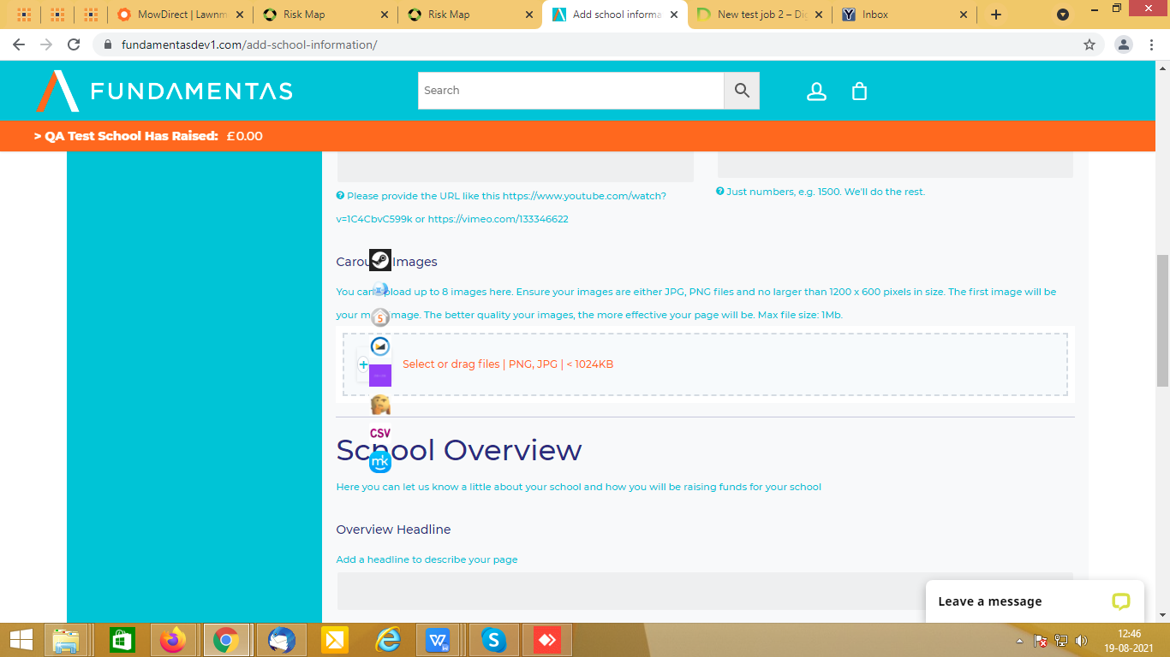

- School page >> Carousel images >> User should not allow to upload more than 8 images.
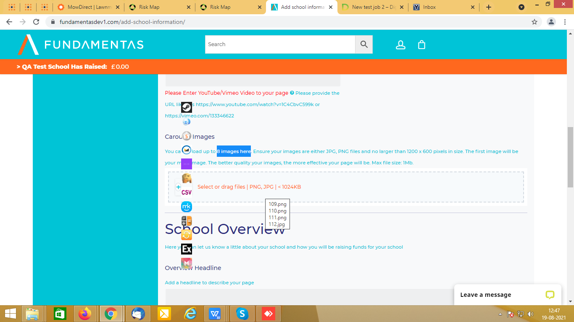

- School information page >> Broken image is displaying for logo.
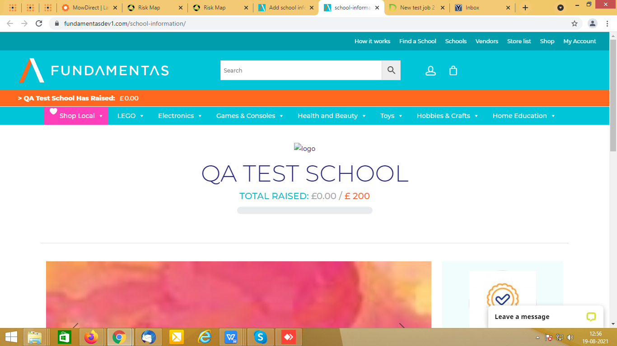

- School information >> Images are not displaying proper in slider and also all uploaded images are not displaying here.
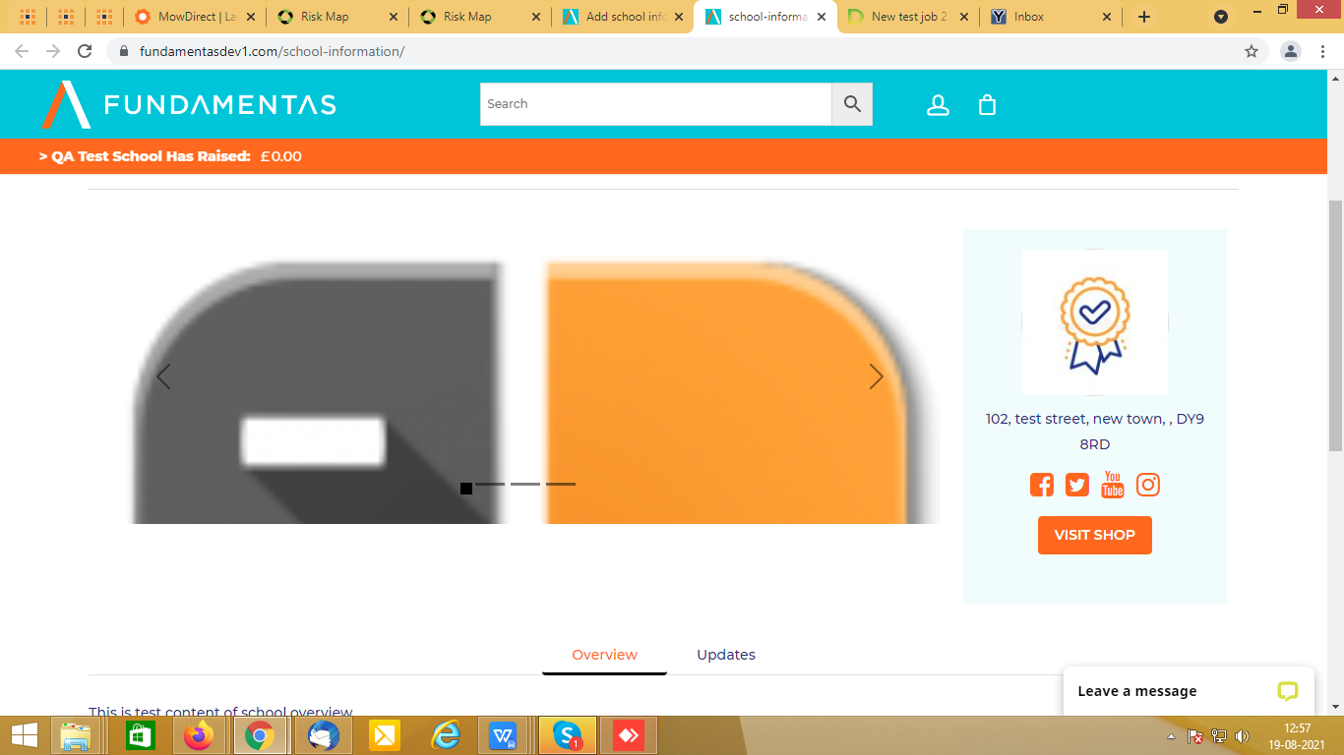

- When user find a school which have completed all details then blank page is appearing.
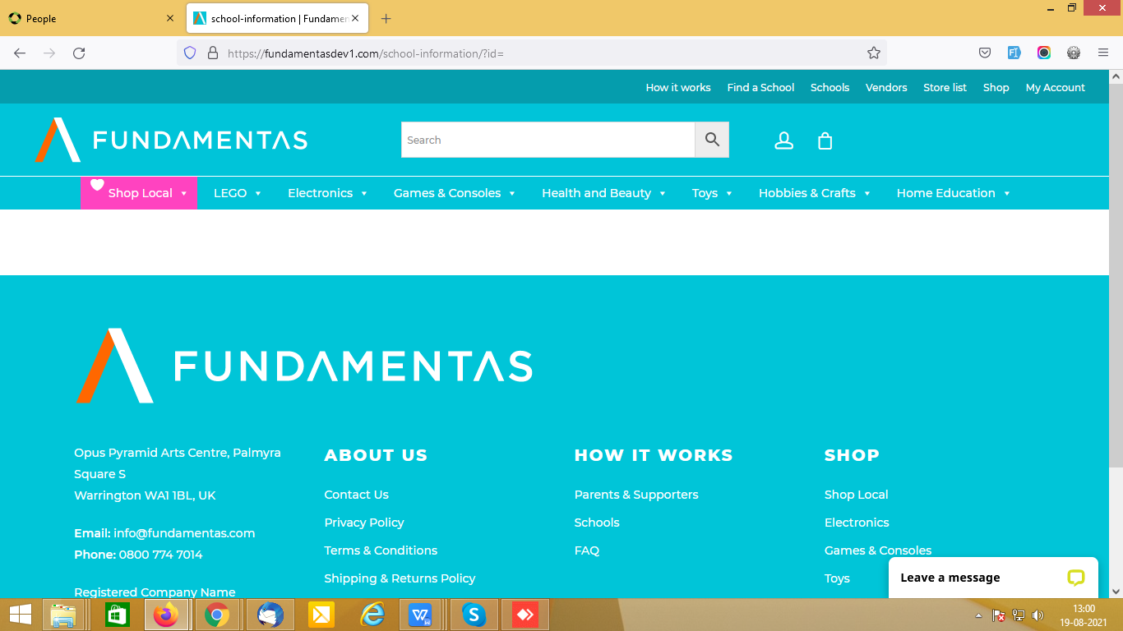

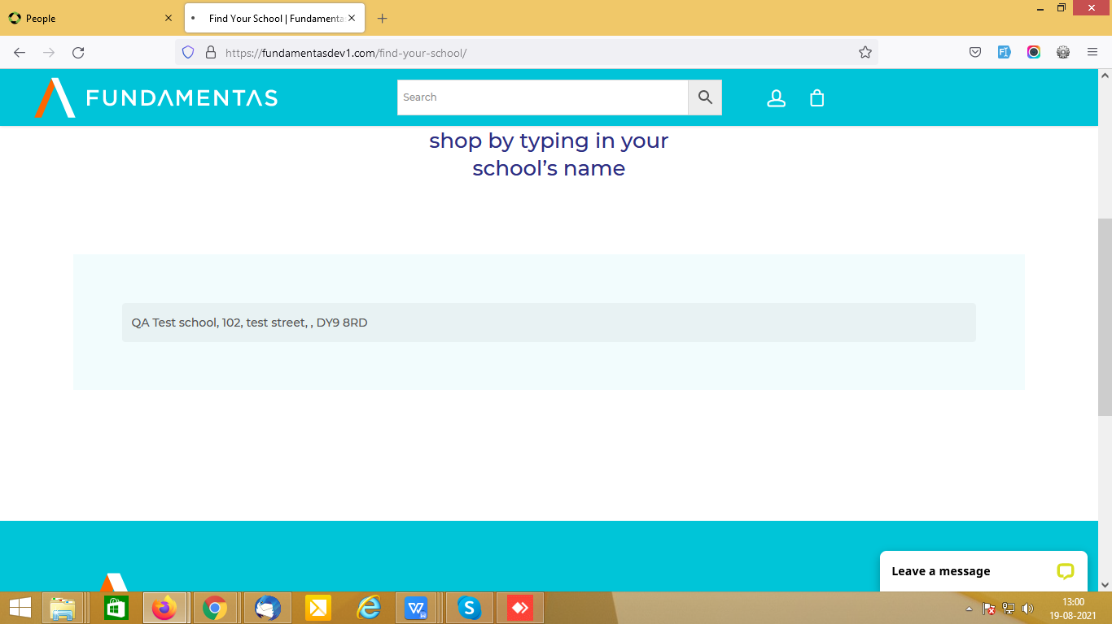

- School information page >> If any data is missing then do not show extra coma.
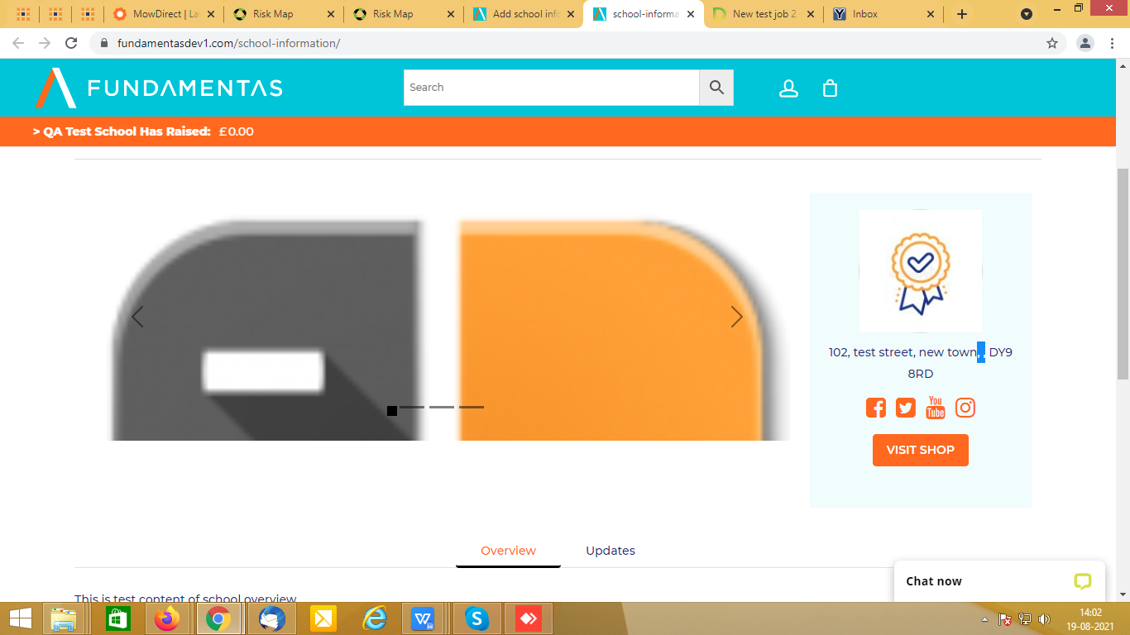

- Add/Edit school page >> Please mention very clearly that user have to enter only user name or complete URL in the social media fields.
