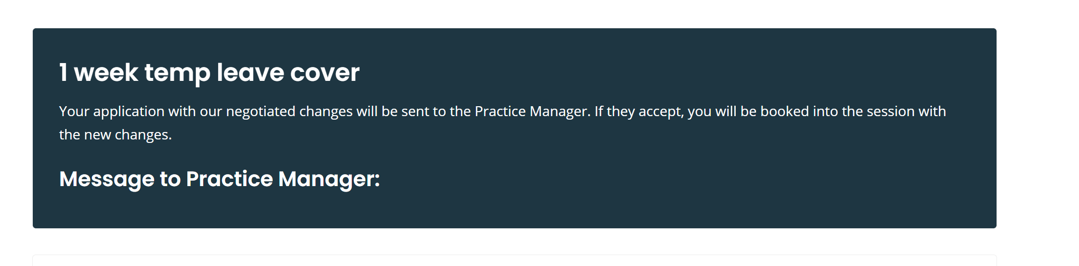
Your application with your proposed changes will be send to the hiring manager. If they accept you will be booked in for the shift(s) in line with the new changes.
-------------------------------------------------------------------------------------------------------------------------------------
Wording for the below;

Remove Hi, I’m interested in working………….. and replace with I’m interested in the following bank agency shift(s)starting on the date below.

However I would like to …….. replace with However, I would like to propose the following changes.

Remove are you happy for me to work as described above, many thanks Fay and replace with Please can you confirm if you are happy with the proposed changes.

I would like to make these spelt wrong.
